**AWS S3**

**By: Kevin Litchmore**

**Create an S3 Bucket**

Step 1: Type S3 in the search box then select S3 (Scalable Storage in the cloud):

Step 2: Click create bucket on the right side of the page:

Step 3: Name the bucket and ensure to use to AWS region of your other instances (Tip: Do not use uppercase letters):

Step 4: Keep the defaults and select “Create bucket”:

**Functionality Verification**

Create two folders and upload data files to the bucket:

Click create folder, designate folder name then select “Create folder”:  
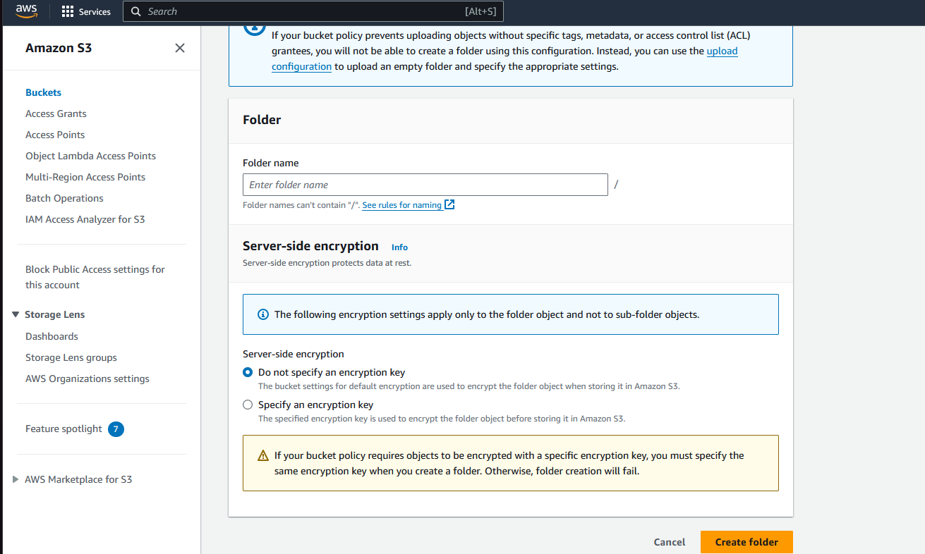

Click on the bucket name then the folder name then “Upload” then Select add files then ensure that the designated file shows up under name then click upload:

The following message will appear when the upload is completed:

